

SIRSYED CASE INSTITUTE OF TECHNOLOGY
ARTIFICIAL INTELLIGENCE
LAB # 02

NAME : LAIBAH RAUF
ROLL NO : 2430-0008
SUBMITTED TO : Maam Warda

Task # 1:

Write a Python script to print a dictionary where the keys are numbers between 1 and 10 (both
included) and the values are square of keys. Sample Dictionary: {1: 1, 2: 4, 3: 9, 4: 16, 5: 25, 6:
36, 7: 49, 8: 64, 9: 81, 10: 100

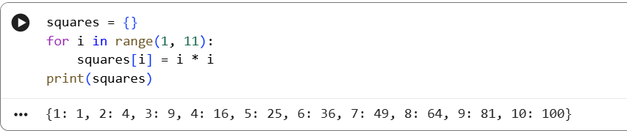

Task # 2:

Create a simple book inventory system using tuples. Each book in the inventory should be
represented as a tuple

book_inventory = []

def add_book():
title = input()
author = input()
year = int(input())
isbn = input()
quantity = int(input())
book = (title, author, year, isbn, quantity)
book_inventory.append(book)

def search_book():
isbn = input()
for book in book_inventory:
if book[3] == isbn:
print(book)
return
print("Book not found")

def display_inventory():
for book in book_inventory:
print(book)

def sell_book():
isbn = input()
qty = int(input())
for i in range(len(book_inventory)):
if book_inventory[i][3] == isbn:
if book_inventory[i][4] >= qty:
updated_book = (
book_inventory[i][0],
book_inventory[i][1],
book_inventory[i][2],
book_inventory[i][3],
book_inventory[i][4] - qty
)
book_inventory[i] = updated_book
print("Sale successful")
else:
print("Insufficient stock")
return
print("Book not found")

add_book()
add_book()
display_inventory()
search_book()
sell_book()
display_inventory()

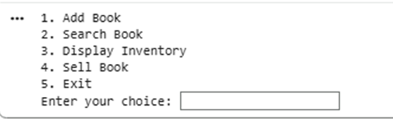
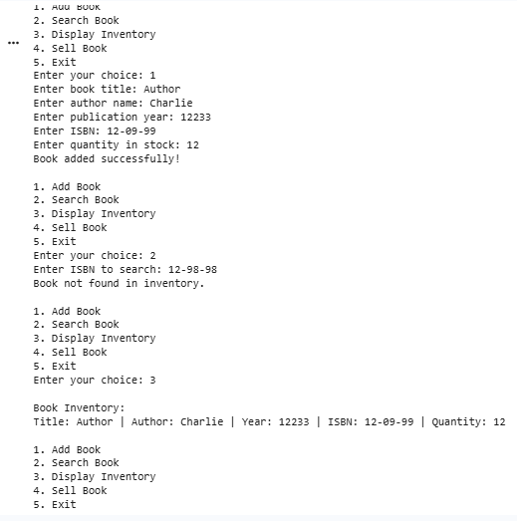

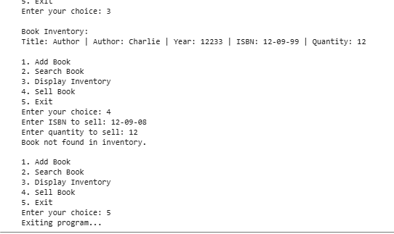

Task # 3:

Add the following graph into the dictionary.

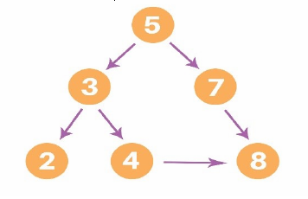

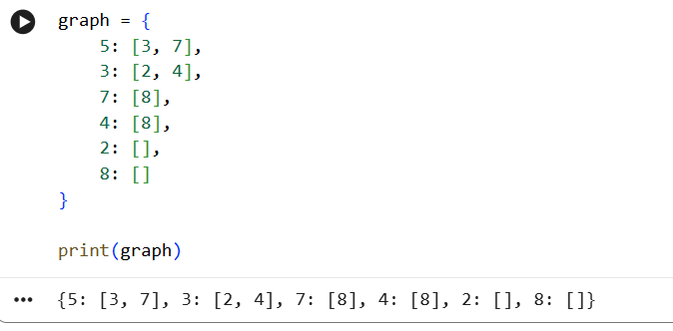

Task # 4:

Add the following graph into the dictionary.

